Witness of Mrs. Irma Scheling
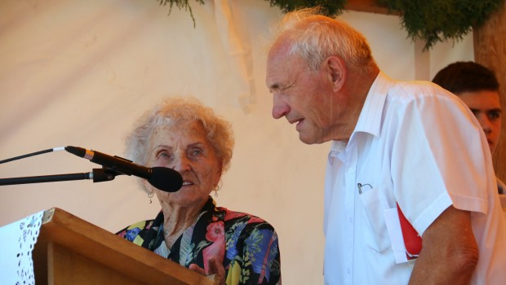
Our visit of Zdenka in the prison in Rimavská Sobota
My husband Cyril Scheling was the brother of blessed Zdenka. He was born as the last child of eleven siblings and he was three years youngerthan she was. They were close to one another in age, as children in the world of young people, and this remained with them for life. Zdenka looked after Cyril from the time he was an infant, when she took him in a rattling cart on bumpy roads up and down the street in Krivá. She was the one who led him by the hand to school on the first school day, and she taught him the first letters and numbers.
They often wrote letters to one another after she left for the convent, and later Cyril considered it his duty to visit Zdenka in Bratislava at least once a year. In July 1947, she begins her letter of congratulation on his name day and the feast of Saints Cyrillus and Methodius in this way:
“Dear beloved brother!
I would like to give you all the beauty of the summer and I would weave in all the loveliness of the flowers into one nosegay and send it to you as a nice gift for your nameday.“
We were a married couple of four years when Zdenka was arrested. My husband Cyril was touched by it very much, but he did not know about her much suffering. No information came to be known through the prison walls. We lived in a homekeeperś lodge near Šafárikovo at that time. After her sentence, she was sent to the womens‘ prison in Šafárikovo, from where she wrote us a short letter with the permission card, that we could send her a one kilo package. We did it with pleasure. Permission cards were sent in this way every month, but after some time they stopped coming. It was then forbidden for Zdenka to receive parcels. Apparently, it was the punishment for her refusal to collaborate at informing about her female co-prisoners.
But one day in the spring of 1953, we received a permission card for a visit. And so we took our two year old daughter, named Zdenka after her religious name. Rimavská Sobota was not far from us when travelling by bus. We were given a cold reception at an inhospitable prison. There was nothing in the visiting room except a long desk. We were waiting there for Zdenka for a moment. She was brought in thick, dark grey prison clothes. She was bony and pale. Next to her stood a uniformed, armed and very brutal prison warden. She warned all of us of all prohibitions, including what we could speak about. Of course, we could not shake hands nor give the parcel we brought.
Zdenka greeted us, smiled and asked how we are, how is our family in Krivá; she was speaking with little Zdenka, too. She would certainly have liked to caress the child and embrace all of us.
We were standing on the other side of the desk and were not able to give any answer. When looking at his sister, all the years of common life, events of common childhood and family flashed through my husband Cyril´s mind. He thought also of the love that she always loaded us with later in her life. When he saw her in such a state and humiliation, his eyes were flooded with tears; and he was not able to say a word. I was feeling the same. It choked us up, squeezed our chests and we were speechless. But it was an expression of emotions not tolerated in the prison and the spiteful warden ordered us to finish the visit.
We came away without saying goodbye. My husband Cyril had tears in his eyes in the bus and also at home and for a long time we did not speak to one another. I was very sorry, because I could not give Zdenka the small parcel. At least she would have had a remembrance of us and improvement on a miserable prison diet. For a long time, we could not carry the burden of brutality, violence and helplessness, and I have it in front of my eyes until this day.
After a short time, Zdenka was driven to Bohemia, to the town of Pardubice, for punishment because she refused to give information against her woman colleagues. We could not visit her there and we did not see her alive anymore. My husband Cyril attended her funeral in Trnava. He came home sad and for a long time he was thinking about everything. I stayed at home with our second daughter.
An old Slovak proverb says, that a person does not choose the family bond. Life´s journey joined me and my husband Cyril, even though it is hundreds of kilometres from the north to the south of Slovakia. Zdenka was with us all the time. He died in 1975 at 56 years old.
Later, at an advanced age, I found myself in the old people´s home in Martin. There, after almost fifty years from the event in the mentioned prison, a woman friend drew my attention to the fact that an older lady, who came after long years in England, had a similar picture of blessed Zdenka as I have on the wall in my room. Of course I went to see her.
“How and from where do you know this sister?“ I asked.
“How would I not know her,“ answered the lady. “We were together in the prison in Pankrác – Prague fifty years ago. It is blessed Sister Zdenka Schelingová and she remained in my memory for my whole life. She was a great woman and I looked after her, when she was operated after being beaten up. Until today I can see her injured and amputated breasts. It was terrible to see. And who are you?“
“I am Irma Schelingová, her sister – in – law.“ I introduced myself to Mrs. Helena Kordová, because such was her name. Maybe many of you will say “A COINCIDENCE!“ I absolutely do not. The management of God‘s ways does not know limits. It was like this in our midst, too. During long hours together Mrs. Helena told me about everything including details that the world should know. That is why the gracious God let her live for such a long time. She died last year at the age of 94 on May 25, 2011. It can never be forgotten.
Irma Schelingová
July 2012
Recorded by: Jozef Habovštiak

Photo = Irma Schelingova Jozef Habovštiak

